Prerequisites : None

Rebuttal : [Chaos Theory](http://todo)

Sequel : [Hedonism](http://todo)

### **On Randomness**

What is randomness? Does randomness exist?

The premise for Determinism is that nothing is random.

Two classic examples of randomness might be rolling a dice or flipping a coin.

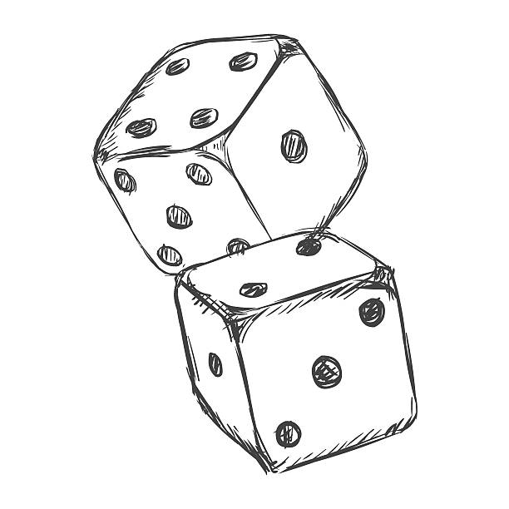

These both produce ‘random’ results but with closer inspection, we can zoom in and realize that these are not truly random events.

We might think that if we knew the strength of gravity, the composition of the dice, the force and angle tossed, the air resistance, air density, air flow, etc; if we were to know every single variable it seems we could predict the outcome with complete accuracy.

In mathematics it’s taught early on that if every variable is known in an equation except one unknown variable, the final variable can be solved for. This is the same case for rolling dice.

(A + B) / (C ^ D) = Result

If we were to know all the variables in the algorithm, mathematically it follows that we could solve for the final variable -- the outcome, effectively predicting the future!

The conceptualization of the term `random` is an event where the outcome is unknowable. In reality, a more accurate definition of randomness might be 'unpredictable' or 'complex'.



An example of a seemingly random event is the weather.

For the longest time weather was a mystery, completely unpredictable. However in the modern day it is commonly forecasted weeks in advance. Did weather become less random over time? What changed?

The difference here is not that the event has changed. The phenomenon of weather has stayed the same, however *our understanding* of it has changed. Our expertise has allowed us to model an algorithm and our technology has allowed us to gather data points to fit into our weather equation.

We can now plug our data points into our new algorithm model to predict the outcome. No longer do we dance or pray or make sacrifices with the expectation that those actions will influence the weather.

Nothing is random

### **Determinism**

Determinism is based upon the above premise that nothing is random. Determinism asserts that every input has a logical, calculable output. Every cause has an effect.

$\int_{a}^{b }{}$ $α÷χ\sqrt[Ψ]{}β + (Ω / λ) = Result$

While things in life may be subject to intensely complex formulas, ultimately if every variable is known, the end result is theoretically calculable.

The premise of determinism is that nothing is random.

Our random number generators are accurately described as pseudo random number generators. Randomness is a theoretical concept. In reality nothing is random.

### **Hedonism**

If we take Determinism and it’s premise that nothing is random it follows that there is a model -- a formula for all things. A model that for an input X, properly derives output Y. While there might be varying, dynamic models for every output Y there exists some model which takes input X and produces output Y.

If we map this onto human behavior there exists a generic human model where plugging in variables leads to predictable individual responses for all circumstances. Hedonism is the name for this model -- the algorithm / formula to derive one’s decisions given the input. This human model - Hedonism - can be described as ‘Happiness’.

This is utilizing language’s high level of abstraction to mask the details, but we’ll explore this more in this article’s sequel ‘Hedonism’.

The relation between the controller and the controlled is reciprocal. The scientist in the laboratory, studying the behavior of a pigeon, designs contingencies and observes their effects. His apparatus exerts a conspicuous control on the pigeon, but we must not overlook the control exerted by the pigeon. The behavior of the pigeon has determined the design of the apparatus and the procedures in which it is used. Some such reciprocal control is characteristic of all science. As Francis Bacon put it, nature to be commanded must be obeyed. The scientist who designs a cyclotron is under the control of the particles he is studying. The behavior with which a parent controls his child, either aversively or through positive reinforcement, is shaped and maintained by the child's responses. A psychotherapist changes the behavior of his patient in ways which have been shaped and maintained by his success in changing that behavior. A government or religion prescribes and imposes sanctions selected by their effectiveness in controlling citizen or communicant. An employer induces his employees to work industriously and carefully with wage systems determined by their effects on behavior. The classroom practices of the teacher are shaped and maintained by the effects on his students. In a very real sense, then, the slave controls the slave driver, the child the parent, the patient the therapist, the citizen the government, the communicant the priest, the employee the employer, and the student the teacher.

<https://www.youtube.com/watch?v=i183B1j_2CY>

Hazey Eyes - Untitled